Development of a Blockchain-Integrated ERP Prototype for AAOIFI-Compliant Murabaha Transactions
1. Abstract
This project addresses the operational risk of non-compliance in Islamic Banks, specifically regarding the sequence of Murabaha contracts. Using Python and cryptographic hashing (SHA-256), a prototype was developed to simulate an Audit Trail that enforces the AAOIFI Standard No. 8. The system mathematically prevents "short-selling" (selling before ownership) by linking transaction timestamps to an immutable ledger.
2. The Problem
In traditional ERP systems used by Islamic banks, it is technically possible for an employee to backdate documents or execute a sale before the bank actually possesses the asset. This violation renders the income "impermissible" (Haram) and poses a significant Sharia audit risk.
3. The Solution (The Algorithm)
I developed a "State Machine" logic using Python that acts as a compliance engine. The system forces a strict chronological order:
- Stage A: Promise to Purchase (Wa'd) - Non-binding.
- Stage B: Bank Possession (Qabd) - Ownership transfer.
- Stage C: Murabaha Sale (Bay') - Cost + Profit.
To ensure transparency, every step generates a Cryptographic Hash. The Hash of Step 2 contains the digital signature of Step 1, creating a "Chain" (Blockchain logic). If anyone tries to alter a previous date, the chain breaks, alerting the auditor.

4. Technical Implementation
- Language: Python 3.12
- Interface: Streamlit (Web Framework)
- Core Logic: hashlib for SHA-256 encryption, pandas for ledger management.
- Key Feature: Immutable Audit Trail Table.
5. Proof of Concept (Screenshots) 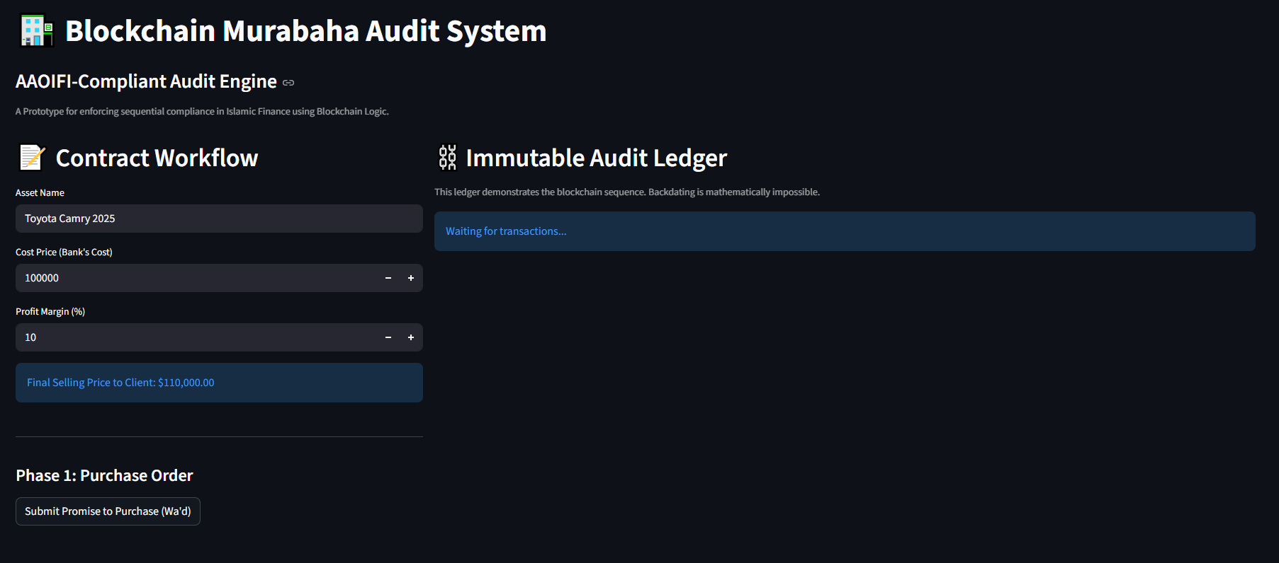
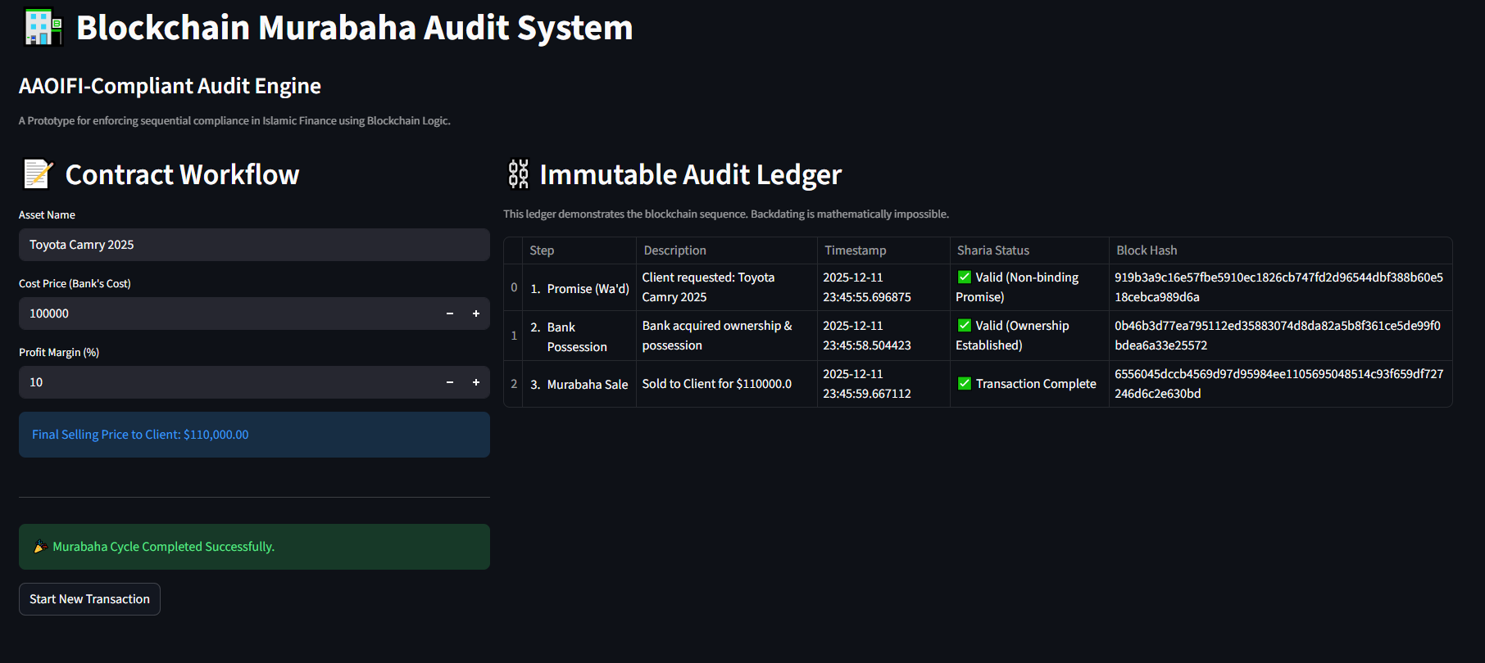
6. Conclusion
This prototype demonstrates that integrating Blockchain logic into Islamic Finance ERPs is not just a theoretical concept but a practical solution to automate Sharia auditing and enhance trust in Islamic Banking products.

